EYFS curriculum Nursery
Nursery
Global theme | Identity and diversity |  | Sustainability |  | Peace and Conflict
 | Moral principle: What makes me unique? How are we all different?  British values: Individual liberty  School values: Success & Perseverance |  | Moral principle: Why should we not waste food? How do we grow our own?  British values: Democracy  School values: Integrity & Resilience |  | Moral principle: What is fair? Why do we have rules?  British values: Respect & Tolerance  School values: Independence & Thoughtfulness
Overarching Topic | All about me  Week 1 &2: Settling In.  Week 3 & 4: From Head To Toe  Week 5 & 6: Owl Babies  Week 7: Peace at last | People who help us  Week 1: School Staff  Week 2: Doctors  Week 4: Mechanics  Week 5: Police Officer  Week 6: Firefighters  Week 7: Postal Worker | Nursery Rhymes  Week 1: The enormous Watermelon  Week 2: Humpty Dumpty  Week3: Incy Wincy  Week 4: This old Man  Week 5: London Bridge  Week 6: Jack and Jill | Lifecycles  Week1 : Life cycle of a Human  Week 2 & 3 : Life Cycle of a butterfly  Week 4: Life cycle of a frog.  Week 5&6: Life Cycle of a chick (Easter) | Dinosaurs  Week 1 & 2: harry and the bucketful of dinosaurs story  Week 3: Saturday Night at the Dinosaur Stomp  Week 4 : Stomp, Chomp, Big Roars! Here Come the Dinosaurs  Week 5: Dinosaur Non-fiction books | Amazing Animals  Week 1 & 2: Zoo Animals  Week 3&4: Farm Animals  Week 5 &6 : Sea Animals  Week 7 & 8: Jungle Animals.
Core texts | From Head to Toe  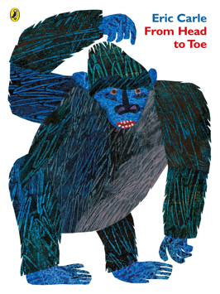  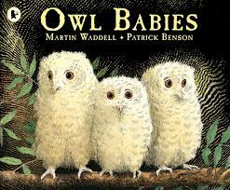  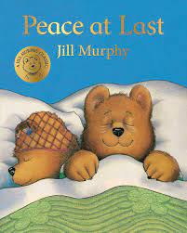 | Non-fiction stories about people who help us  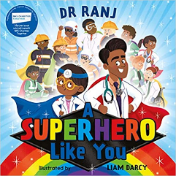  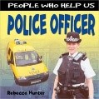  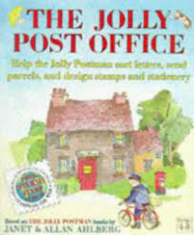 | The Enormous Watermelon  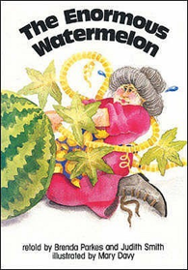 | The Very Hungry Caterpillar  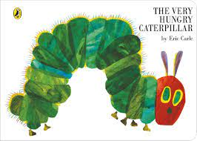 | Harry and the bucketful of dinosaurs  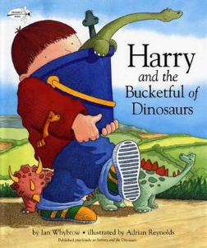 | Brown Bear Brown Bear, what do you see?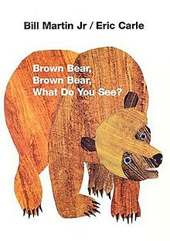  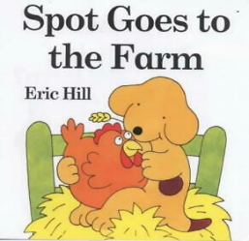  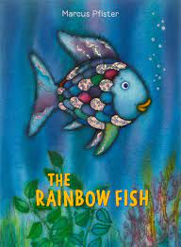
Core Vocabulary | Body Parts- Head, Shoulders, Knees, Toes ,leg, foot, eyes, Mouth, lips, ears, teeth, hands, fingers  Family names  Mum, dad, brother, sister, uncle, aunty, grandma, granddad, cousin | Teachers, caretakers, Canteen, Cleaners  Doctor, Nurse  Mechanic  Police officer  Firefighter  Postal worker | Rhymes, characters, singing, | Growth, Life cycle, change, minibeast  baby, toddler, child, adult, older person,  Days of the week, caterpillars, cocoon, butterfly,  Tadpole, froglet, frog  Chicks, egg, hatch |  | Animals, habitat, Jungle, forest, zoo  Farm
Experiences | Starting and settling into Nursery.  Exploring our new learning environment. | People from different occupations to visit the children.  EYFS Christmas  Nativity | Have a Nursery rhyme party. | A visit from live Caterpillars, watch the life cycle of a butterfly. | Transform Nursery into Dinosaur world.  Mystery Postman brings a parcel  A Vist from Dinosaur Dome | A visit from Zoo lab.  Trip to Aldeham country farm  Nursery Graduation Ceremony
Parent partnership | Braintcroft expectations Meeting  Parents settle children each Morning/Afternoon.  Tapestry Workshop & Class Dojo  Parent and Child home project. | Paddington's Adventure  Parent Workshop  EYFS Nativity  Parent and Child home project. | Reading Session  Parent Workshop  Paddington's Adventure  Parent and Child home project. | Reading Session  World Book Day  Paddington's Adventure  Phonics Stay and Play (watch lesson and stay to play after)  Parent and Child home project. | Reading Session  Paddington's Adventure  Parent Workshop  Parent and Child home project. | Reading Session  Graduation celebration  Paddington's Adventure  Sports Day  Inviting parents on our teddy bear picnic.  Parent and Child home project.
Communication and Language | Communication and language are not taught discretely; speaking, listening and understanding skill are entwined in all areas of learning
Personal, social, emotional development  Jigsaw themes | Beginning to make relationships.  Separate from our parents’ careers.  Explore new environment – select activities.  British Values Link:  We are learning to all be a Nursery family where we:  All have equal rights, the right to choose, have our own ideas and voice, follow the same rules and respect each other.  Being Me in my World  *Feelings  *How our action affect others.  *Belonging  *Our Rights | Making relationships.  Selecting resources.  Sharing.  Talking about likes, dislikes.  Feelings  Introduce team work.  Know that actions can hurt others feelings. – Rule of Law.  All of the above links to our British Values T+L: Democracy, Individual liberty, Mutual Respect, Rule of Law.  Celebrating Difference  What am I good at?  I’m Special  Family  Home | Interest in others, playing together and sharing ideas – Mutual Respect, Individual Liberty:  Respond to what other children are saying.  Discuss feelings –Develop turn taking and sharing  Encourage conversations about home life.  Dream and Goals  Challenge  Never give up  Setting goals  Obstacles and the future. | Building on strong Relationships to develop each other’s play.  Respond to other children’s wants and needs – Rule of Law, Mutual Respect.  Managing feelings and behavior.  Understanding feelings.  Encourage conversations about home life – link to daily talking time – Learning to celebrate our differences in terms of culture and religions  Healthy Me  Exploring our bodies  Being Healthy  Sleep  Washing hands  No to strangers | Play in a bigger group – building on each other’s play. Mutual Respect, Individual Liberty  Carrying out small tasks for others.  Begin to adapt to changes happening to become  Relationships  Family  Making Friends  Being a kind friend  What makes a kind friend, does not make a kind friend | Aware of own feelings  Confident to speak to others about own needs, wants, interests and opinions.  Can describe self in positive terms and talk about abilities.  Confident to talk to other children when playing, and will communicate freely about own home and community.  Changing Me  Parts of my body  How I am changing and growing  Starting School
Physical development | Begin to ask to go to the toilet.  Wash and dry our hands.  Put on our coat independently.  Learn to use Nursery climbing equipment.  Malleable play to support fine motor skills.  Gross motor movement – Squatting, running safely, climbing. Moving body in lots of different ways.  Beginning to use three fingers to hold a writing tool.  Drawing a simple shape. | Draws lines and circles using gross motor movements.  Use one-handed tools and equipment, e.g. make snips in paper with child scissors.  Developing self care using toilet.  Beginning to use tools safely.  Drawing lines and circles using gross motor movements. | Sorting healthy and unhealthy food.  Moves freely around equipment and with pleasure and confidence in a range of ways, such as slithering, shuffling, rolling, crawling, walking, running, jumping, skipping, sliding and hopping.  .  Using pencils daily – grip/control.  use of tools. | Can copy some letters, e.g. letters from their name.  Running races in playground to build their spatial awareness and coordination.  Balance Bikes Learning to ride a bike.  Parachute games.  Drawing circles using gross motor movements.  Copying letters from name and others- ongoing. | Weekly ‘Cooking’ to include Healthy eating and hygiene.  Understand how to use equipment safely by making pirate obstacle courses, handling planks, crates and equipment.  Use of tools – use with more control.  Pencil grip/control  Letter formation  Effects of activity on the body. | Ring games such as Duck, Duck Goose.  Using Scooters-to learn to balance. Reception climbing frame to develop their ability to climb up steps and down poles/across ropes etc.  Throwing and catching a ball/bean bag.  Pencil grip/control  Letter formation  Effects of activity on the body
Literacy  Reading | Phase 1  Listens with interest to stories.  *Joining in with stories.  *Repeating key words and phrases  Enjoys looking at a range of books independently.  Explore Environmental Sounds, Body percussion, Instrumental Sounds  *Singing Nursery Rhymes. | Phase 1  Recognise their name (With Picture card)  Rhythm and Rhyme,  *and rhythmic Rhyming activities –  *Introduce concept of rhyme.  *Story re-tell  *Rhythm in words  *Handling books carefully – turning pages. | Phase 1  Children learn to ask questions, listen to other and express their opinion.  Order letters from own name  Knows that print carries meaning and key words – letter/word  Introduce oral blending. Model oral blending and initial sounds in daily Nursery practise  Plays with rhyming words and alliteration | Phase 1  Beginning- middle- end  Describes main story settings, events and principal characters.  *Rhyme +Alliteration. Voice Sounds.  *Describes main story events and principal characters. *Suggests how the story might end building confidence.  *Story structure | Begin RWI –set 1  Retell the story through role play and to use story language  Sequencing a story.  RWI- Introduce sounds. | RWI Phonics – Set 1  To start to develop awareness between fiction and non-fiction books.  Orally blend and begin to segment familiar words.  *Knows information can be relayed in the form of print.  *Holds books the correct way up and turns pages.  *Knows that print carries meaning and, in English, is read from left to right and top to bottom.
Literacy  Writing | To develop children fine motor skills through exploring different activities to build up the muscles in their hands.  Emergent mark making – develop confidence in making marks using a range of different tools and mediums.  Drawing their family. | To expose children to a variety of mark-making and to show children the marks they make are meaningful. | To develop children to start recognising their name and encourage to mark make to recognise their name.  Encourage children to make marks in writing area – give meaning to marks.  *Focus on name writing, dinosaur name writing, writing about our knowledge linked to Dinosaurs.  Shopping lists for the dinosaur stomp.  *Begin to introduce giving meaning to the marks in their environment. | Daily writing name practice.  Beginning to form letters correctly.  Ascribe meaning to marks they see in different places.  Making marks for a range of different purposes – letter, invitation, list, postcard. | Writes own name and other things such as labels, captions.  Begins to learn letter shapes to corresponding RWI rhymes and pictures for Set 1 sounds and be able to write some of these.  Orally blend and begin to segment  Recognise some initial sounds.  Encourage children to make marks in writing area – give meaning to marks.  *Focus on name writing, dinosaur name writing, writing about our knowledge linked to Dinosaurs.  Shopping lists for the dinosaur stomp.  *Use of initial sounds in writing. | Learning to recognise and blend and segment sounds (Phonemes) in order to read and write words.  Recognising letters and names and signs all around us.  Use of initial sounds in writing.  Use of letters in writing.  Ascribe meaning to marks
Maths | Number songs and Rhymes. Begins to represent number using pictures and marks on paper.  Count all children in class on a daily basis.  Shape Feely Bag game – 2D Shapes. | Saying number names in order when singing, playing games or in rhyme  Number rhymes  Begin to match number and quantity  Numbers in the environment – show interest.  Number recognition  Counting a small number of objects  Shape hunt walk around school. Draw simple shapes.  Language of size  Anticipate time-based events  Compare simple quantities – introduce language ‘same’ ‘more’ ‘less’ ‘few’ ‘fewer.’ | Sing Number Rhymes-Recites numbers in order to 10.  Counting a small number of objects after placing them in a line.  Matching number and quantity more independently.  Comparing 2 groups of objects and saying when they have the same number.  Beginning to talk about the shapes of everyday objects, e.g., ‘round’ and ‘tall’  Understanding positional language | Compares two groups of objects, saying when they have the same number.  Focus on matching number and quantity correctly.  Recording numbers Show interest in number problems.  Begin to separate a group of 3 or 4 objects in different ways recognising that the number is still the same.  Comparing sizes small/medium/large.  Comparing length: Long, short, longest, shortest. | Recognises some numerals  Matches numeral and quantity.  Mark-make to write numerals  Use comparative language to compare  Find the total of 2 sets of objects | Realises not only objects but also anything can be counted including steps, claps or jumps  Finding Shapes and patterns in the environment.  Naming and describing 3D Shapes.
UW Past and present  History link | Talk about who is in their family  Learn about different celebrations.  To remember and talk about significant events in their own experiences – birthday’s, traditions, key celebrations, this may even include days out, visits to key places – these are all ‘historical’ events for the children that have taken place in their past. | Look at what clothing for people who help us looked like in the past.  Look at different roles and responsibilities of people who help us from the past.  What festivals and celebrations do different people celebrate and why? Christmas, Diwali, Weddings, new births. | Look at Nursery rhymes from the past. Share rhymes that parents and Grandparents sang as children. | Recognises and describes special times or events for family or friends. | To identify some similarities and differences between ways of life at a different time, such as in the Jurassic and cretaceous periods when Dinosaurs roamed the Earth instead of humans.  Dinosaurs used to walk the earth – a long time ago, in the past -they no longer do now. (extinct)  Develop knowledge about dinosaur’s habitat, diet, movement, daily life, communication.  Use, explore, talk and ask questions about historical sources, such as photographs, the internet, books and artefacts to find out things that are from the past. | Know that some animals have become extinct.  To remember and talk about significant events in their own experiences – focus on the history of our Nursery year.  Reflect and revisit special times and changes.
UW People, places, community  Geography link | Show a map and link them to their home country.  To be able to comment and ask questions about aspects of their familiar world, such as the place that they live.  Talk about key features within their own local area – such as places and objects that they pass on the way to school each day, shops, signs, traffic lights, a hill, a park, a road etc. | What police, Doctors and Firefighters uniform and transport looks like around the world | Chinese New Year-stories and activities; lanterns, dragons and Chinese food such as noodles to make and use. | Easter, look at celebrations and traditions- Easter around the world. | Begin to compare different dinosaur environments – forest, desert, sea.  Explore the changes in weather when dinosaurs walked the earth – hot, dry weather that changed to cooler, wetter conditions. | What animals live in England?  Nature walk  Visit to the park  Explore/compare– what is a forest, desert, the sea?
UW The natural world  Science link | Talk about our body parts and the purpose of each part.  Oral hygiene | Fire Safety  How a fire can start, what we need to do to keep ourselves safe. | Explore and describe different materials.  Know that substances – such as water and foods can be changed over time if they get too hot or too cold. | Caring for living things.  Understanding growth and decay  Life-Cycle of a butterfly | Talks about why things happen and how things work.  •Know that if you push or pull something it will move. (Forces in action – PD, water/sand.)  •Know that if you push something hard it will go faster, or slower if you push something softer.  •Know that if you push something it will move in the direction that you push it. | Know that animals have similarities and differences and can be grouped for different reasons: habitats, feeding- link learning to dinosaurs and animals that they may have as pets: dogs, cats, rabbits.
EAD  Art and Design | Introduce mark making equipment collage, paint, crayon etc.  Paint a self portrait  Make sensory toys (shakers, glitter bottles etc) | Exploring colour and how colours can be changed colour mixing activities.  Christmas Creative activities to develop fine motor control. | Collage print painting using different fruits and vegetables  Cooking – growing and cooking food | Exploring paint and different brush strokes  Making minibeast from Junk Modelling | Explore paint and how to create different animal prints | Make paper masks of different fairy tale characters for role play  Make a fabric animal puppet.
EAD  Music link  Nursery Rhymes | Explore sound using different instructions and parts of their body. | Christmas songs and Jingles. | Learning well known nursery rhymes and songs | Learning to makes different animal noises using body percussion | Learn to create different animal noises using a variety of instruments | Explores and learns how sounds can be changed, through using and playing musical instruments.
EAD  Role play | Home corner | School  Mechanics Police station  Doctors Surgery  Fire station  Chistmas Post office | The enormous Watermelon  Week  2: Humpty Dumpty  Week 4: This old Man  Week 5: London Bridge  Week 6: Jack and Jill | Garden Centre  Mini-beast hut. | Dinosaur museum. | Zoo role-play  Jungle Role-play  Under the Sea Role- Play

