EYFS Curriculum Reception
Global goal link | Identity and diversity
 | Moral principle: What makes me unique? How are we all different?  British values: Individual liberty  School values: Success & Perseverance |  | Moral principle: Why should we not waste food? How do we grow our own?  British values: Democracy  School values: Integrity & Resilience |  | Moral principle: What is fair? Why do we have rules?  British values: Respect & Tolerance  School values: Independence & Thoughtfulness
Overarching Topic | All about me | Celebrations  Week 1 and 2: Diwali/ Guy Fawkes  Week 3 and 4: Birthday  Week 5: Hannukah  Week 6 and 7 Christmas | Food | Growth and Change  Week 1 and 2:  Seasons  Week 3-6: Planting | Amazing Animals | Traditional tales  Week 1 and 2: Goldi locks and the three bears  Week 3 and 4:  The ginger bread man  Week 5 and 6:  Little red riding hood
Core text | 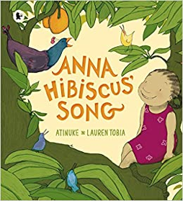 | 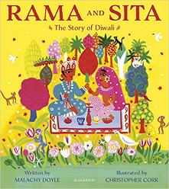 | 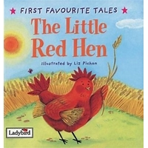 | 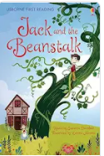 | Walking through the jungle.  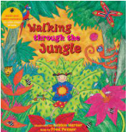 | Goldilocks and the three bears.  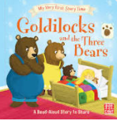
Additional texts |  | 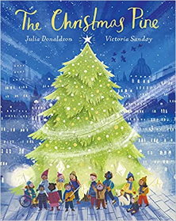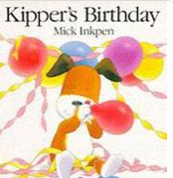 | 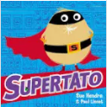  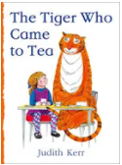 | 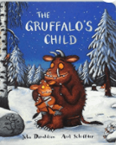 | 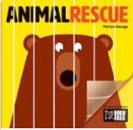  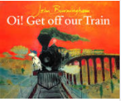 | 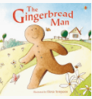  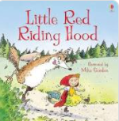  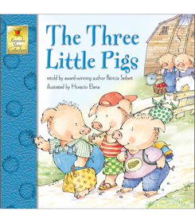
Core Vocabulary | Me, my family, brother, sister, mother, father, baby, toddler, child, adult, older person, map, area. | Celebrations, cultures, festivals, Diwali, rangoli, fireworks, birthday, party, cake, balloons, Hannaukah, candle, light, Christmas, Santa, gifts | Healthy, unhealthy, Vegetable/fruit names, growth, animals, farms, supermarkets. | Growing, seed, seasons, weather, environment, green house, germinate, planting | Animal names, endangered, poachers, captivity, clothing, danger, habitat, environment, diet, | Traditional tale, beginning, middle, end, once upon a time, setting, character. Author, illustrator moral.
Experiences | Parents to visit us to share tales and share cultural food. | Write a letter to Santa and post it.  Christmas Nativity | Prepping soil and environment project.  Visit from a gardener. | Caring for baby chicks.  Growing: cress, mustard, broad beans, tomatoes, Rosemary, thyme, mint, other herbs in our reception garden then use them in cooking.  Visit Welsh Harp/Garden Centre | London Zoo | Making 3D models using different materials.  Picnic at the park with parents.  Special visit from an Author.
Parent partnership | Braintcroft expectations Meeting  Tapestry Workshop & Class Dojo  Parents come in and talk about where they are from.  Parents read/ tell stories from their culture.  Parent’s Termly Workshop  Parent and Child home project. | Parent’s Termly Workshop  Parent and Child home project.  EYFS Nativity | Parent’s Termly Workshop  Parent and Child home project. | Reading Session  World Book Day  Parent’s Termly Workshop  Parent and Child home project. | Parent’s Termly Workshop  Parent and Child home project. | Parent’s Termly Workshop  Parent and Child home project.  Sports Day  Parent and Child home project.  End of year celebration.
Communication and Language | Communication and language is not taught discretely; speaking, listening and understanding skill are entwined in all areas of learning
Personal, social, emotional development  Jigsaw themes | Being me in my world | Celebrating difference | Dreams and goals | Healthy me | Relationships | Changing me
Physical development | Go to the toilet independently.  Wash and dry our hands independently.  Begin to put on our clothing independently. Do zips/buttons on coats interpedently.  Learn to use reception climbing equipment safely.  Malleable play to support fine motor skills. | Develop core strength through digging in our outdoor area using a variety of different tools and equipment.  Children will have the opportunity to weave on a large and small scale.  Use one-handed tools and equipment, e.g. make snips in paper with child scissors.  Begin to form letters/ letter like shapes using the RWI program. | Sorting healthy and unhealthy food.  Moves freely around equipment and with pleasure and confidence in a range of ways, such as slithering, shuffling, rolling, crawling, walking, running, jumping, skipping, sliding and hopping with increasing skills, balance and coordination. | Can copy some letters, e.g. letters from their name.  Running races in playground to build their spatial awareness and coordination.  Balance Bikes Learning to ride a bike.  Parachute games. | Weekly ‘Cooking’ to include Healthy eating and hygiene following a simple recipe.  Managing risks in our outdoor area when travelling and moving in different ways. | Throwing and catching a ball/bean bag.  Aiming, kicking a ball.
Literacy  Reading  Follow RWI program. | Explore a range of different books.  Use and understand vocabulary in nursery rhymes.  Reading and identifying logos, and text around the environment. | Follow RWI program.  Begin to read simple CVC words.  Talking about books. | Use our phonics to read. | To use our phonics to read simple captions and sentences | To talk about what they have read. | To develop fluency when reading texts.
Phonics | Know most Set 1 sounds and begin to blend (Set 1 single letter Sounds Group A/B) | Know Set 1 Sounds and blending (Set 1 single letter Sounds and blending Group B/C) | Reading Photocopy Ditties 1–20* | Reading Red Ditty Storybooks | Reading Green Storybooks | July: reading Green/Purple Storybooks
Literacy  Writing | Baseline - consolidate 3-4 outcomes  Use some of their print and letter knowledge in their early writing.  Write some or all of their name.  Write some letters correctly. | *Initial sounds and final sounds.  *HA: CVC words.  *Begins to break the flow of speech in to words – early sentence writing skills.  *Basic skills: Practise writing clear identifiable letters.  *Be able to write own name.  *Explore what a sentence looks like -introduce capital letter, finger space, full stop, | *CVC words.  *Write a rhyming string.  *Basic skills: Practise writing clear identifiable letters.  *Begin to focus on building a sentence – ‘I am a cat.’  *To independently write in meaningful contexts for a range of purposes.  *Begin to use key word banks in writing. Yellow-orange.  *Use some punctuation with support in a sentence. | *To write a simple sentence independently – applying skills taught.  *Use phonic knowledge to write words that match their spoken sound.  *Write some irregular common words.  *Begin to use key word banks in writing. Yellow-green.  *Use some punctuation with more independence in a sentence. | * Consolidate all ELG Writing outcomes.  *Spell some words correctly as well as making phonetically plausible attempts.  *Story writing. | *Focus on consolidating ELG outcomes.  *Transition in to year 1 Reading skills.
Maths | Counting 0-10  We will begin to recognise numbers.  Count objects, actions and sounds. | Counting beyond 10. Counting out objects to match to the numeral.  Looking at Length and  Patterns.  2D Shapes and positional language. | Comparing amounts (more/less), order numbers 1-10, find & say 1 more up to 10  Recognizing how many objects without counting.  Weight, capacity | Adding 2 groups together. 1 more/1 less.  Count beyond 20  Explore 2D and 3D shapes | Learn numbers bonds up to 5.  Subtracting, adding, doubling, halving | Number bonds to 10.  Explore odd and even numbers
UW Past and present  History link | Children to know that they were all babies, toddlers and small children. That when they grow up they will be adults and grow old (cycle of life).  Children look at picture of themselves as babies and younger children and other people in their families. | Compare how festivals are celebrated now and in the past. | History of farming equipment and practices and how people obtain food now and in the past. | Exploring how recycling materials will help the environment.  Composting? And waste food? | Explore how animals have changed over time and animal life cycles. | History of different traditional tales and they have influenced cultures and changed over time.
UW People, places, community  Geography link | Map of our home and local area.  Journey to school/ around the school. | Discuss own experiences of celebrating festivals. | Where different food comes from.  Awareness of different types farms.  Compare urban and rural | Explore different conditions for plants to grow. (desert vs polar regions) | Explore animal habitats within our local area and around the world. | Explore traditional stories from different countries.
UW People, places and community  RE link | What makes a person special? |  | What makes a day special? |  | What makes a story special?
UW The natural world  Science link | Labelling parts of the body.  Discussing parts of the body and what they do.  Exploring our senses  Oral hygiene | Light and dark. Exploring natural verses artificial light.  Exploring shadows. | Growing different seeds, looking after the plants.  How food decays and decomposes. | Observe and know about seasonal changes  Growing different seeds, looking after the plants.  Learn different parts of the plant. | Lifecyle of chicks. | Explore materials, their properties and how they are used for different purposes.  What would be the best material to build a house? Why?
EAD  Art link | Draw a Self-portrait with increasing control  Artist: Andy Warhol and recreate using the same technique | Colour mixing, skills for painting. | Printing using different food and material. | Artist: Van Gogh and recreate using the same technique | Explore and recreate animal patterns using various techniques and materials. | Explore art from different cultures.
EAD  DT link | Make a puppet. | Create Rangoli patterns  Make cards  Create Christmas decorations | Cooking using a simple recipe | 3D models of the sunflower. | Junk Modeling - animals | Design and build houses fpr the 3 little pigs
EAD  Music link  Nursery Rhymes | Exploring rhyme and rhythm in our fav nursery rhymes.  Explore body percussion and instruments to play with rhymes. | Christmas concert and nativity | Little Red Hen song.  Explore rhythm | Hello Mr Sun song, with musical instruments and explore tempo and pitch and following the Melady. | Perform Down in the jungle with actions. | Children use musical instruments to retell the story. Use music to express mood and feelings.
EAD  Role play | Home corner | Diwali home  Birthday party  Christmas grotto | Fruit and veg stall | Garden center | Zoo/Safari | Fairytale cottage

